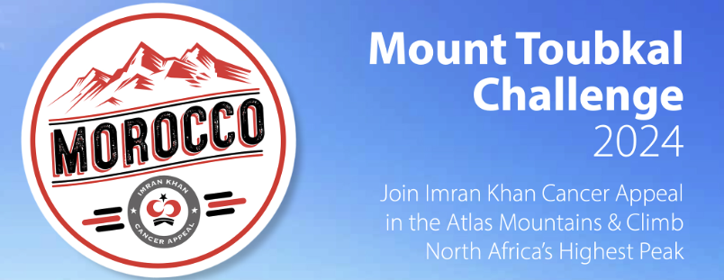

**Application** **Form**

Please secure a place for me on the Imran Khan Cancer Appeal (IKCA) Mount Toubkal Challenge 2024 (Morocco)

Title ________ First Name ______________________ Surname _______________________

Address ____________________________________________________________________

_______________________________________________________ Postcode ____________

Telephone _____________________ Email________________________________________

Date of Birth_______________ Passport No. ____________ Expiry Date ________________

Dietary requirements _________________________________________________________

Allergies____________________________________________________________________

Medical conditions ___________________________________________________________

In case if emergency please contact:

Name ___________________________________________ Tel _______________________

Name ___________________________________________ Tel _______________________

Please describe your fitness level – do you go to the gym/walk/run regularly? Have you climbed any mountains before, if so, which? Have you completed any physical endurance challenges previously (e.g., marathons/triathlons), if so, which? _______________________

___________________________________________________________________________

Page **1** of **4**

**Terms** **&** **Conditions:**

1. **BOOKING:** The application form above must be completed in full and signed. A non-refundable deposit of £150 must be made by card or by bank transfer to: Barclays Bank, Sort Code: 20-37-83 A/c No: 40550256 A/c Name: Shaukat Khanum Memorial Trust. The signed application form should be returned via email or post.

2. **AUTHORITY:** By registering for this trip, you agree to accept the authority and decisions of our employees, tour leaders, agents, and suppliers during the trip. If, in the assessment of any of these people, your health or conduct appears likely to endanger the health, well-being and progress of the trip, yourself, and/or others, we reserve the right to exclude you from the trip (in whole or part). In the case of ill-health, we reserve the right to make such arrangements for your well-being as we deem necessary and to recover the whole of the costs thereof from you.

3. **ACCEPTANCE** **OF** **RISK**: Your booking is accepted on the understanding that:

(a) You are aware that the adventure trip, in addition to the usual dangers and risks inherent has certain additional dangers and risks, some of which may include:

• Physical exertion for which you may not be prepared

• Weather extremes subject to sudden and unexpected change

• Remoteness from normal medical services

• Evacuation difficulties if you are disabled

(b) You acknowledge that the enjoyment and excitement of adventure travel is derived in part from the inherent risks incurred by travelling and undertaking activities beyond the levels of safety normal at home or work, and that these inherent risks contribute to such enjoyment and excitement, being a reason for your participation.

(c) You acknowledge that the nature of this type of travel requires considerable flexibility, and you must allow for alternatives. The outline itinerary provided for the trip is only an indication of what each group may accomplish and does not form a contractual obligation on the part of IKCA.

(d) You understand that the route, schedules, itineraries, amenities, and modes of transport may be subject to alteration without prior notice due to local circumstances or events, such as sickness, mechanical breakdown, flight cancellations, etc.

4. **CONFIRMATION:** Your place on the event is not secured until; (i) IKCA is in receipt of the signed and completed registration form. (ii) And until you have received a confirmation letter from IKCA stating that your place has been secured. This is subject to the rights reserved in point 5.

Page **2** of **4**

5. **RIGHT:** IKCA reserves the right to not accept a participant onto a challenge at any point leading up to departure of the trip. If, while on the UK training challenges, it is assessed and identified that you may not be in full readiness to undertake this challenge, IKCA also reserve the right to reject a secured participant. If such an assessment is made, your secured place will be deferred to the following year’s challenge, and you will be notified of this within a reasonable timeframe.

Participants will normally only be accepted if they are at least 18 years of age by the first day of the trip. IKCA reserve the right to request evidence of suitability to undertake the physical challenge. IKCA shall not be liable for any failure to perform the contract due to unusual and unforeseeable circumstances beyond the control of IKCA, or our suppliers, the consequences of which could not have been avoided even if all due care had been exercised; including but not limited to war, threat of war, riot, civil strife, industrial dispute including air traffic control disputes, terrorist activity, natural and nuclear disaster, fire, adverse or threat of adverse weather conditions, technical problems with transport, closure or congestion of airports or ports.

6. **RESPONSIBILITY:** In respect of land-only clients (meaning those people not starting with the group from UK), our responsibility does not commence until you arrive at the designated meeting point. If you fail to arrive there at the appointed time, we shall not be responsible for any additional expenses incurred by you to meet up with the group.

7. **FUNDRAISING** **TARGET:** The fundraising target must be reached by **1 September 2024**, unless IKCA has agreed to extend the deadline. All payments must be in pounds sterling. If the full target is not received on time, IKCA reserves the right to cancel the booking and forfeit the deposit without notice. All necessary travel documents must be sent by recorded post to IKCA, PO Box 786, 66 Little Horton Lane Bradford BD5 0YE.

8. **CANCELLATION:** For cancellation applicants are required to send a request letter stating reasonable grounds, signed, and dated. Cancellations will be subject to a levied charge relative to the date of departure as follows:

a) From the day of booking to 90 days before the date of departure 10% of the full package price will be charged.

b) 29-42 days before the date of departure 50% of the full package price will be charged. c) 0-14 days before the date of departure 90% of the full package price will be charged.

**9.** **DELAYS** **AND** **CHANGES** **TO** **DATES/RATES:** Times that we have provided are tentative and delays may occur from time to time. You are requested to abide by the times appointed by your group leader, as that would override our times. Date changes are extremely rare and usually result from bad weather conditions, rescheduling times by the airlines, action by air traffic controllers, mechanical fault, or industrial actions, all of which are beyond our control. Imran Khan Cancer Appeal is not to be held responsible in any way for the loss or the invalidity of connecting tickets/flights due to any delays beyond our control. It is your responsibility to ensure that your luggage weight is within the carrier’s allowance; extra weight is chargeable by the airline and must be paid to them directly upon request. We are not responsible for freighting your baggage, and we do not give credit or lend money nor are we responsible for any lost baggage.

Page **3** of **4**

**10.** **ACCOMMODATION:** The accommodation at the hotels in Morocco will be based on twin sharing; two persons per room. For the rest of the journey, the accommodation will be at mountain cabins and tents.

**11.** **DISPUTE** **RESOLUTION:** Imran Khan Cancer Appeal pledges to make your trip a success, Inshallah. In case of any dispute or if you are not happy with the services provided, you agree to resolve it internally with organisers. Before either party causes to be published to any third-party any difficulty, dispute or difference or commences any proceedings against the other party arising out of or in connection with this Agreement, the parties shall attempt to negotiate in good faith. If no written settlement is agreed within seven days from the date on which the complaint is first received, both parties shall apply to a 1st Resolve Director to nominate independent Resolver(s) and refer the complaint.

**12.** **JURISDICTION:** This contract shall be governed by and construed in accordance with English Law and any dispute shall be subject to the exclusive jurisdiction of the English courts.

**DECLARATION:**

I agree to abide by this Agreement with Imran Khan Cancer Appeal (IKCA), incorporating the terms and conditions above, and I understand that the dates and package rates are subject to change. I have read and understood the terms and conditions above and can confirm that the information I give above is true to the best of my knowledge.

Signed: ________________________________________ Date: _______________________

*All dates and rates are subject to confirmation upon airline timings and confirmation. *Please print the application form, sign, scan and return by email or post.

Page **4** of **4**